27.69: a) 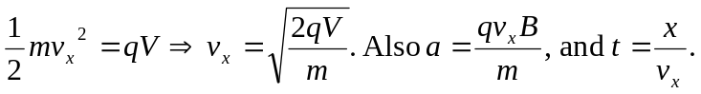
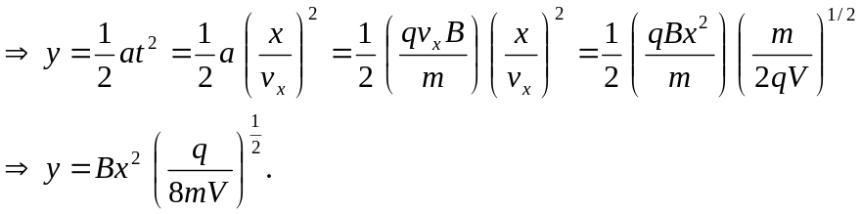
b) This can be used for isotope separation since the mass in the denominator leads to different locations for different isotopes.

